Project Design Phase-II
Data Flow Diagram & User Stories
Date | 22 September 2026
Team ID | SWTID-2026-4802
Project Name | FitTrack

Data Flow Diagrams:
A Data Flow Diagram (DFD) is a traditional visual representation of the information flows within a system. It shows how data enters and leaves the FitTrack system, how the information is processed, and where fitness data is stored.
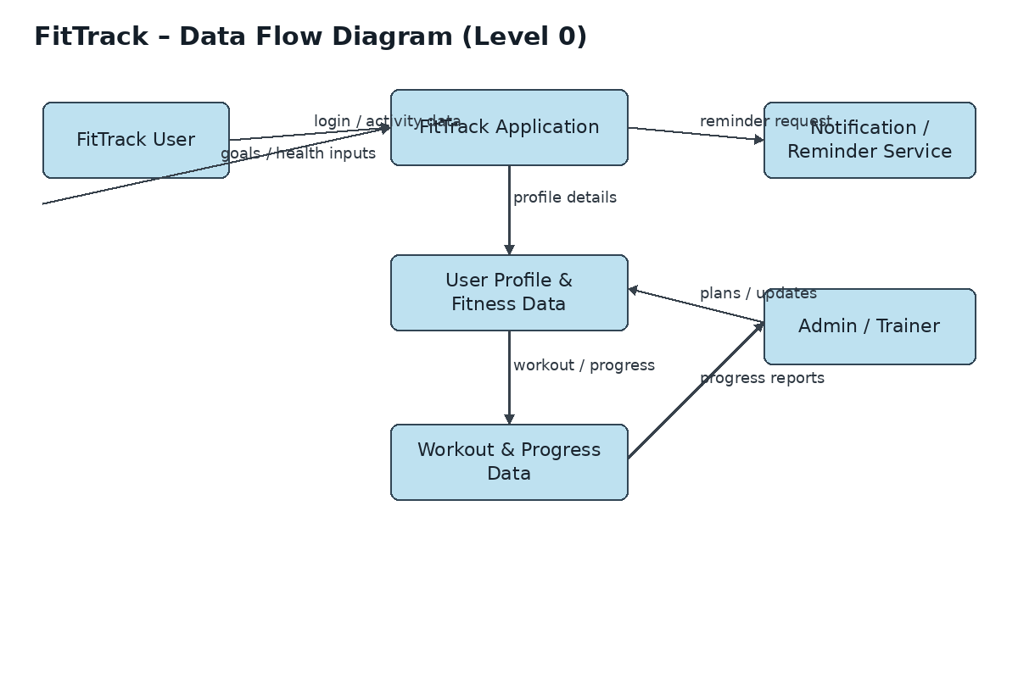
FitTrack DFD – Level 0
User Stories
The following user stories describe the main FitTrack functions.
User Type | Functional Requirement (Epic) | User Story Number | User Story / Task | Acceptance criteria | Priority | Release
Customer (Mobile/Web user) | Registration | USN-1 | As a user, I can register for FitTrack using my email and password. | I can access my account/dashboard | High | Sprint-1
 | Registration | USN-2 | As a user, I can confirm my account through email or OTP. | My account is confirmed successfully | High | Sprint-1
 | Login | USN-3 | As a user, I can log into FitTrack using my email and password. | I can access the dashboard | High | Sprint-1
 | Profile | USN-4 | As a user, I can create and update my fitness profile and goals. | My profile and goals are saved | High | Sprint-1
 | Workout Tracking | USN-5 | As a user, I can record my workouts and activities. | Workout details are stored | High | Sprint-2
 | Progress Tracking | USN-6 | As a user, I can view my fitness progress and workout history. | Progress information is displayed | High | Sprint-2
 | Goals | USN-7 | As a user, I can set fitness goals and track their completion. | Goal status is updated | Medium | Sprint-2
 | Reminders | USN-8 | As a user, I can receive reminders for planned workouts. | Reminder is received | Medium | Sprint-3
 | Dashboard | USN-9 | As a user, I can view my activity summary on the dashboard. | Daily/weekly summary is displayed | High | Sprint-3

